Minutes to the Board of Directors Meeting
September 28, 2026
Chair of the board Chris Johnson calls the meeting to order at 9:00 a.m.
- Roll call and confirmation of Quorum.
Chris Johnson, Ruth Ann LeFebvre, Kat Crockett, Eddie McArthur and Scott Harris are all in attendance and the Board has a quorum.
- Pledge of Allegiance to the Flag.
- Call to the public.
- Members of the public are invited to address the Board and/or submit written comments for inclusion in the minutes. Members of the Board shall not discuss or take legal action on matters raised during an open call to the public, unless the matters are properly noticed on the agenda for discussion and legal action.
- Charles McChesney a Solar Wrangler for the Babacomari Ranch Co. addressed the Board: Charles spoke about the trend for Babacomari’s cattle ranching being down by 40%, and consequently increasing the Solar Farming on the ranch. The decrease in cattle on the Babacomari can be attributed to the drought over the last few years.
- Approval of the Minutes from past meetings-
- Minutes from the August 24th, 2026 are presented for review and approval.
Eddie McCarthur moves to approve the minutes from the August 24th Board meeting, Ruth Ann LeFebvre seconds the motion and it’s approved unanimously.

5. Reports from the Fire Chief or his designee may include the following topics:
- 2024-2026 Strategic Plan
• Plan extended through 2027.
• 20thAnniversary celebration today immediately following the Board meeting.
Administration/Budget:
- Our existing workers comp provider is exiting the market. We have signed on with a new carrier effective in October with a significant annual savings
- Enhancements to the rolling access gate are scheduled for this week. We created a temporary pathway to the back of the station during the construction
Santa Cruz County CWPP Update:
- Matrix Consulting was selected to conduct the Emergency Services audit for the county. The work should begin in October and is scheduled to take 18 weeks.
- The Treasurer’s office has been updating their software systems, resulting in a significant delay in processing revenue payments. We are currently owed July and August. They hope to have the situation resolved by the end of this month.
Pima County Updates:
- Pima County will be providing prevention patrol funding to fire departments. Projected start date will be spring 2027, IGA will be ready for Board review in August.
- On behalf of the department, I signed the updated Community Wildfire Protection Plan for the County.
- I attended the September Supervisors meeting where they proclaimed today SEFD day in Pima County.
- PSPRS Local Board:
• The Local Board met last month and will meet again in the spring.
- Operations:
• Equipment:
- The first out Hurst spreader tool is out of service pending a repair, crews are using the back up in the interim.
- EMS:
- All agencies will be required to obtain their own DEA numbers and be directly responsible for all aspects of controlled substances in response to a new federal and state law. We are working with our base hospital to comply.
• Staffing:
- Captains testing will take place in October.
- Captain Sapienza, FF Barker and FF Jackson attended the annual Arizona State Fire School at the beginning of the month, taking classes on suppression, inspection and live fire training.
- AC Hart completed the five-day Struggle Well training.
- Chief is also teaching an EMT class in Nogales and am providing remote mentoring to paramedic students through Pima College.
- District Growth/Development:
  - Planned subdivisions: Papago Springs, AZ 82(removed commercial element). AZ 82 (preliminary water requirements review completed).
  - Proposed Dude Ranches: Babacomari (no updates). Double R Ranch (new and in County approval process).
  - Proposed Wineries • Brigand (moving forward, SEFD has approved plans)
  - Dollar General Remodel (SEFD has approved plans).
- Neighboring Agency News & Developments: Town of Patagonia Update: PVFR receiving a one-year contract for services to the town. We will continue to work with them and look for opportunities to enhance service to that community.
- Total incidents for the month of August we ended at 61 incidents and here is the breakdown: FIRE-5, MEDICAL-36, HAZARDOUS CONDITION-0, RESCUE-0, PUBLIC SERVICE-14, NO EMERGENCY- 5, AND ASSISTING LAW ENFORCEMENT-1. Incident count by Zone: Zone 1 had 23, Zone 2 had 6, Zone 3 had 6, Zone 4 had 2, and Zone 5 had 23 and zone 6 had 1 for a total of 61. Under incident count by day, the busiest days of the week were Saturday and Monday, with Friday trending the next highest and most calls running during the day. There were 48 incidents during the day and 13 incidents during the night hours. For comparison, the month of August ended in 50 calls in 2024, and 61 calls in 2025.
- Certificate of Necessity (CON):
- Submitted a grant request via AZ DEMA to acquire computers and associated equipment towards compliance with HB2609.
- Renewal of our CON happened this month and we should have confirmation in the next couple of weeks.
- Legislative Update:
- HB2766 Special District Fairness and Accessibility Act- clarifies that special tax districts are local units of government for grant funding purposes (AFDA support).

- Presentation and Approval of Monthly Financial Reconciliation and Reports pursuant to ARS Sec. 48-807 including:
• reconciled balance sheet accounts;
• month-end statements;
• month-end balances at all institutions and county accounts;
• revenues and expenditures; and
• cash flow projection report.

- Financials will be tabled until the October, we did not receive the Santa Cruz County Tax Statement for August and so we don’t have consolidated financials for September’s presentation. Ben Archer Clowes spoke to the Board about the effect of the delay of tax disbursement and to date it is not having a negative effect due to the money we have in reserve.

- United Firefighters of Sonoita Update to Board.
- Tim Hart the union president to present to the Board. This past month the union did a meet and confirm meeting to create a MOU, the first step in the process. Part #1 is getting close to completion and then there will be two more parts with benefits and pay/financials. Union dues will increase to $31.39; it’s currently at $30.42. Suicide Prevention month is September and still remains an issue in our industry and we need to remain conscious of and take care of our folks. The union is very happy about getting our technology upgraded with two new STARLINK mobile devices for the first out Ambulance and Engine.

- Presentation, discussion and possible action – Update of SEFD HR Policy Handbook.
- The SEFD HR Policy has been updated to include any Board approved updates and achieve consistent language throughout. Chief explains that he reviewed the updated HR Policy, Tricia reviewed and SEFD legal counsel.
- On the following three pages are the changes to the Human Resources Policy Manual that were revised for review with the Board:
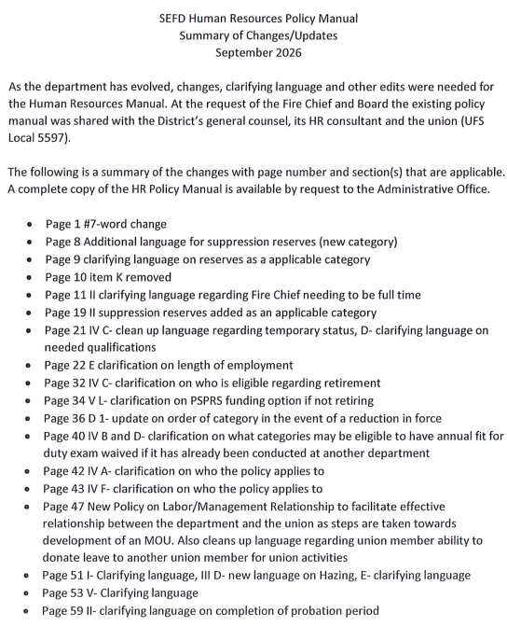
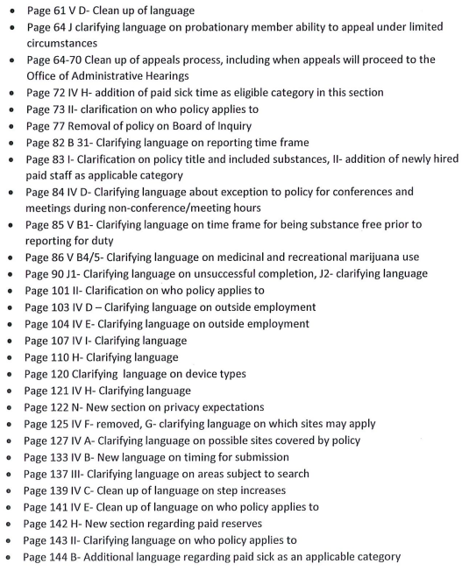
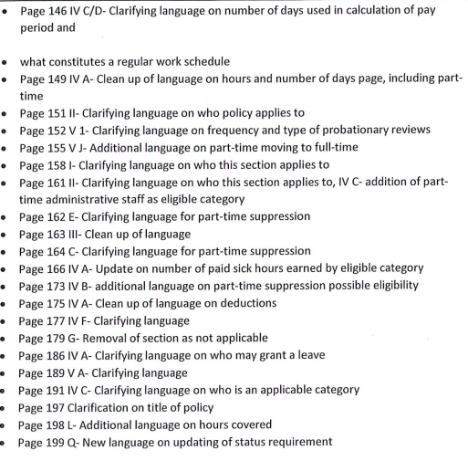
Eddie McArthur moves to adopt the update Human Resources Policy Manual, Kat Crockett seconds the motion and the motion is unanimously approved.

- Information item- Oath and badge pinning for FF Barker.

- Presentation, discussion and possible action - funding request, not to exceed $75,000, for starting and completing Phase I of the Elgin Fire Resources Facility.
- Chief is tabling item number ten due to needing more time to get estimates and bids for Phase l. Chief’s last conversation with the two firms that will have numbers for us, was they said it would be soon.

- Consideration of possible future agenda items.
- Elgin property development updates.
- Financials and updates from Santa Cruz County Treasurer’s Office.

Scott Harris moves to adjourn the meeting; Kat Crockett seconds the motion and the motion is carried without opposition.
Chris Johnson adjourns the meeting at 10:25 a.m.
A digital copy of this meeting is available to the public at the Sonoita-Elgin Fire District, located at 3137 AZ Highway 83 Sonoita, AZ 85637

NOTICE: The Sonoita-Elgin Fire District Board of Directors may go into executive session for the purpose of obtaining legal advice from the fire district’s attorney(s) on any of the above agenda items pursuant to A.R.S. 38-431.03(A)(3)
Minutes approved by________________________, Board Clerk, on ___________
Ruth Ann LeFebvre Date

